**STUDENT PERFORMANCE ANALYSIS DASHBOARD REPORT**

**DAX FUNCTION:**

DAX (Data Analysis Expressions) plays a crucial role in **Power BI** for creating custom calculations, measures, and calculated columns to derive meaningful insights from data. It allows users to perform advanced data analysis by using functions to filter, aggregate, and manipulate data dynamically, enabling more powerful and interactive reporting.

AverageExamScorePerStudent =

CALCULATE(

AVERAGE('StudentPerformanceFactors infos'[Exam_Score]),

ALLEXCEPT('StudentPerformanceFactors infos','StudentPerformanceFactors infos'[Hours_Studied])

)

This DAX function calculates the **average exam score** for each unique value of the column **Hours_Studied**. It does so by ignoring all other filters on the table except for **Hours_Studied.**

Result = IF('StudentPerformanceFactors infos'[Exam_Score] >= 65, "pass","fail")

This DAX function assigns "pass" if a student's exam score is 65 or above, otherwise "fail”

Eligibility = IF('StudentPerformanceFactors infos'[Attendance] >= 75, "Eligible ","Not eligible")

This DAX function returns "Eligible" if a student's attendance is 75% or higher, otherwise "Not eligible."

This DAX function labels performance as "Improved" if the exam score is higher than previous scores, "Not improved" if lower, and "Unchanged" if they are the same.

AvgExamScoreByGender = CALCULATE(AVERAGE('StudentPerformanceFactors infos'[exam_score]), 'StudentPerformanceFactors infos'[gender] ="Male")

PerformanceCategory =

IF(

'StudentPerformanceFactors infos'[Exam_Score] > 'StudentPerformanceFactors infos'[Previous_Scores],

"Improved",

IF(

'StudentPerformanceFactors infos'[Exam_Score] < 'StudentPerformanceFactorsinfos'[Previous_Scores],

"Not improved",

"No Change"

) )

This DAX function calculates the average exam score for students who are male.

HighAttendanceCount =

COUNTROWS(FILTER(''StudentPerformanceFactors infos ', ''StudentPerformanceFactors infos '[attendance] > 90))

This DAX function counts the number of students with an attendance rate greater than 90%.

ExamScoreLearningDisabilities =

CALCULATE(AVERAGE(''StudentPerformanceFactors infos '[exam_score]), ''StudentPerformanceFactors infos '[learning_disabilities] = "Yes")

This DAX function calculates the average exam score for students identified as having learning disabilities.

Student Category =

IF( 'StudentPerformanceFactors infos'[Exam_Score] > 90,

"Topper",

"Slow Learner"

)

This DAX function categorizes students as "Topper" if their exam score is greater than 90; otherwise, they are labeled as "Slow Learner."

In conclusion, using DAX functions enables us to perform detailed analysis on student performance data by calculating averages, categorizing students, and filtering based on various criteria such as exam scores, attendance, and learning disabilities. These functions allow for efficient and dynamic reporting, helping to identify key trends like improvement in performance, eligibility for specific conditions, and grouping students based on their achievements.

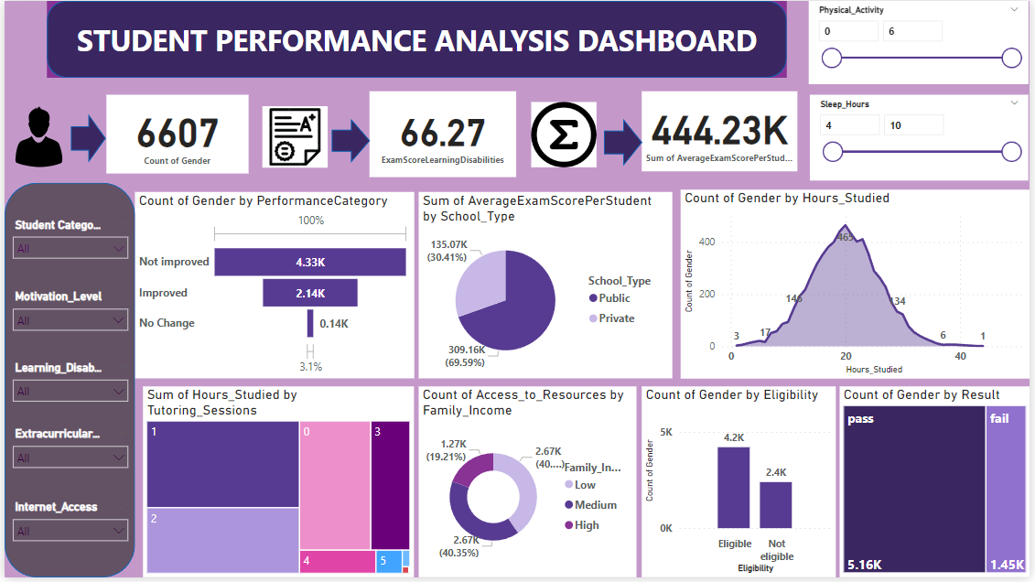

YAMINI V